Jedi Knight II
Jedi Outcast

The following are a list of conventions that we must adhere to in order to obtain consistency in our models’ construction and avoid having to waste time either programming around inconsistencies or waste artists’ time re-doing work.

- All humanoid skeletons must use consistent naming and alignment of bones.
- Texture coordinates are not required to be asymmetrical. (i.e. you can mirror them.)
- There are only 9 allowed root surfaces: hip, l_leg, r_leg, torso, head, r_arm, r_hand, l_arm and l_hand. These are the splits needed for dismemberment. These root surfaces are labeled in white caps on Figure 1. The hierarchy of these surfaces is indicated by the white arrows. All other surfaces must be children of one of these root surfaces. (revision note: in figure one the hips/leg split is no longer at the crotch, as illustrated, it has been moved to the knee in the final game).
- Children of a root surface must be named with the root surface’s name as a prefix. For example, in Figure 1, the shoulder pad is called r_arm_shpad. All child surfaces are labeled in white lower-case lettering.
- There are 9 root surface tags that are needed. These are indicated by a green “X” in Figure 1. These tags’ orientation is indicated by the green arrow coming out of them (axis-alignment is discussed later). Naming of a tag is as follows: “bolt_<parent surface name>[_additional name]”. The “additional name” part if optional and should be used only if the tag needs a more descriptive name (or if there are multiple tags on the same surface). Hence, the tag for the left hand is named simply “bolt_l_hand” but the tags on the left knee and left foot are named, respectively, “bolt_l_leg_knee” and “bolt_l_leg_foot”. These names are labeled in green lower-case italics in Figure 1. All tags must be children of their associated surface.
- All surface splits must have caps on either end.
- Caps must be named in the following manner: “<parent surface>_cap_<adjoining surface>”. So, as with other child surfaces, the cap’s name begins with the parent surface name as a prefix. The second part of the name is “_cap_” and the last part of the name is the name of the root surface that the cap borders. For example, in the “Anatomy of a Surface Split” box in Figure 1, the cap on the right arm between the right arm and the right hand is called “r_arm_cap_r_hand”.
- Caps that are on root surfaces (the splits used for dismemberment) must also have tags. The tag must be at the center of the cap and must point away from the surface. Like all tags, naming for these tags is as follows: “bolt_<cap surface name>”. Hence, the tag on the aforementioned cap on the right arm between the right arm and the right hand is called “bolt_r_arm_cap_r_hand”.

Figure 1 is on the next page

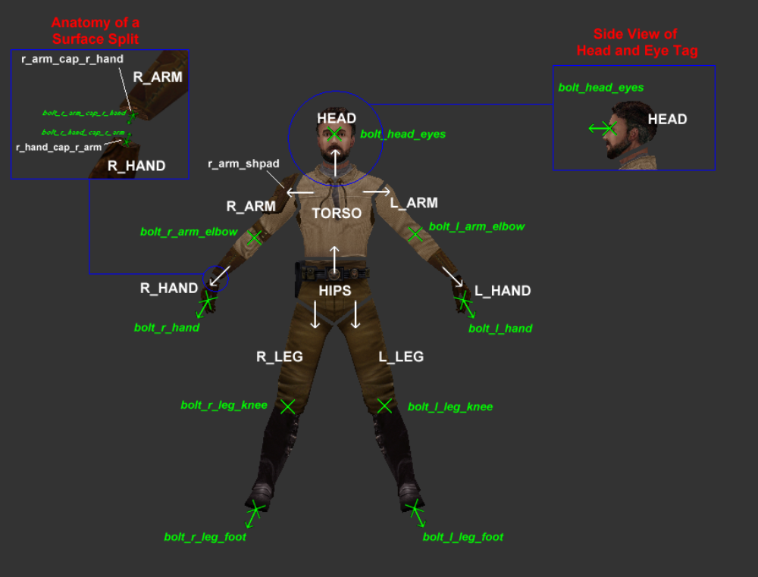 Figure 1
- Axis alignment is as follows: negative y is forward, negative x is right and positive z is up. See Figure 2 for an illustration of this. Note that the red, green and blue axis color corresponds with the colors of these axes in ModView. Figure 3 indicates how the tag surface should be aligned.

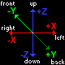
Figure 2
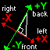
Figure 3

